Bestseller product for males.

Query SELECT t.CID, SUM(t.Quantity) as total FROM `transaction` as t inner join customer as c on t.CID = c.CID WHERE c.Gender = 'Male' GROUP BY t.PID ORDER BY SUM(t.Quantity) DESC limit 1;

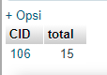

Bestseller product for females.

Query: SELECT t.CID, SUM(t.Quantity) as total FROM `transaction` as t inner join customer as c on t.CID = c.CID WHERE c.Gender = 'Female' GROUP BY t.PID ORDER BY SUM(t.Quantity) DESC limit 1;

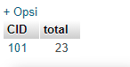

A customer with CID that spends the most money.

Query:

SELECT t.CID, SUM(t.Total_Price) as total FROM `transaction` as t inner join customer as c on t.CID = c.CID GROUP BY t.PID ORDER BY SUM(t.Total_Price) DESC limit 1;

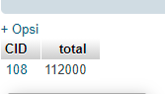

Several transactions for every 2 hours. At 14.00.00-16.00.00 o'clock, there are 11 transactions. At 16.00.00-18.00.00 o'clock, there are 2 transactions. At 18.00.00-16.00.00 o'clock there are 2 transactions. At 20.00.00 o'clock and above there are 2 transactions.

SELECT Floor(Hour(Time)/2)*2, COUNT(*) FROM transaction GROUP BY Floor(Hour(Time)/2);

